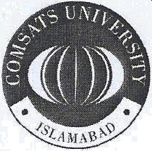
COMSATS University Islamabad, Lahore Campus

Department of Pharmacy

Ref. No CIIT/FA23-PHM-104/LHR Dated 04-05-2026

Subject: Professional training (Internship) for Pharm. D. student

Dear Sir/Madam
COMSATS University Islamabad, Lahore campus (CUI) believes in the advancement of learning and extending the frontiers of knowledge through education in an academically diverse range of disciplines. CUI holds seven fully functional campuses, including the Lahore Campus.
It is to certify that Mr. Ejaz Aslam s /o Mr. Muhammad Aslam Registration No. CIIT-FA23-PHM-104 LHR is a regular & bonafide student of the CUI. He is studying in 4th semester, Doctor of Pharmacy program at this campus.

The minimum duration of this program is 10 semesters (05 Years) and the medium of instruction & examinations for the said program is English.
This certificate is being issued at the request of the applicant.


Regards


D . Yasser Shahzad associate Professor/Head Department of Pharmacy
COMSATS University Islamabad, Lahore Campus Email: yshahzad@cuilahore.edu.pk

1.5 km Defence Road, OERawind Road, Lahore54000 Punja b, Pakistan
Tel UAN: +92 (42) 111-001-007 Tel: +92 (42) 99203104, 99203105, 99203106
FAX: +92 (42) 99203100

